Project Design Phase-II
Data Flow Diagram & User Stories

Date | 19 February 2026
Team ID | LTVIP2026TMIDS87010
Project Name | Calculating Family Expenses using ServiceNow
Maximum Marks | 4 Marks

Data Flow Diagrams:
A Data Flow Diagram (DFD) represents how expense data flows through the system.
In this project, the DFD shows how family expense data is entered by users, processed by the ServiceNow platform, stored in tables, and finally displayed as reports.
Example: (Simplified)
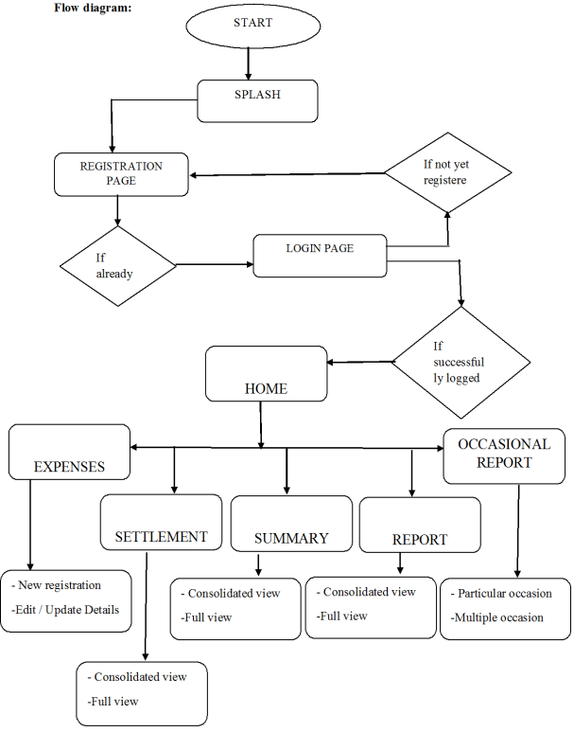

User Stories
Use the below template to list all the user stories for the product.
User Type | Functional Requirement (Epic) | User Story No. | User Story / Task | Acceptance Criteria | Priority | Release
Family User | User Login | USN-1 | As a user, I can log in to ServiceNow using my credentials. | User successfully logs in | High | Sprint-1
Family User | Expense Entry | USN-2 | As a user, I can add daily family expenses. | Expense record is saved | High | Sprint-1
Family User | Expense Categorization | USN-3 | As a user, I can select expense category while entering data. | Category is stored correctly | Medium | Sprint-1
Family User | Expense View | USN-4 | As a user, I can view entered expenses. | Expense list is displayed | Medium | Sprint-2
Administrator | User Management | USN-5 | As an admin, I can create users and assign roles. | Users and roles created | High | Sprint-1
Administrator | Approval Workflow | USN-6 | As an admin, I can approve or reject expenses. | Expense status updated | Medium | Sprint-2
Administrator | Reports | USN-7 | As an admin, I can generate monthly expense reports. | Report generated successfully | High | Sprint-2

